**Clinical Decision Support (CDS) Content and Health Level 7 (HL7)-compliant Knowledge Artifacts (KNARTs)**

**General E-Consult Clinical Content White Paper**

**Department of Veterans Affairs (VA)**



**Knowledge Based Systems (KBS)**

**Office of Informatics and Information Governance (OIIG)**

**Clinical Decision Support (CDS)**

**Clinical Decision Support (CDS) Content and Health Level 7 (HL7)-compliant Knowledge Artifacts (KNARTs): General E-Consult Clinical Content White Paper**

by Department of Veterans Affairs (VA)

Publication date April 2018

**Contract: VA118-16-D-1008, Task Order (TO): VA-118-16-F-1008-0007**

**Table 1. Relevant KNART Information: General E-Consult**

| **KNART Name** | **Associated CLIN** |
| --- | --- |
| General E-Consult - Documentation Template | CLIN0005AA |

**Table of Contents**

VA Subject Matter Expert (SME) Panel vi

Introduction vii

Conventions Used viii

1. General E-Consult 1

1.1. Clinical Context 1

1.2. Knowledge Artifacts 1

2. Documentation Template: E-Consult Request 3

2.1. Knowledge Narrative 3

2.2. E-Consult Request 3

Bibliography/Evidence 8

A. Existing Sample VA Artifacts 9

B. Acronyms 22

**List of Figures**

A.1. E-Consult Instructions (Image 1 of 13) 9

A.2. E- Consult Instructions (Image 2 of 13) 10

A.3. E- Consult Instructions (Image 3 of 13) 11

A.4. E- Consult Instructions (Image 4 of 13) 12

A.5. E-Consult Instructions (Image 5 of 13) 13

A.6. E-Consult Instructions (Image 6 of 13) 14

A.7. E-Consult Instructions (Image 7 of 13) 15

A.8. E-Consult Instructions (Image 8 of 13) 16

A.9. E-Consult Instructions (Image 9 of 13) 17

A.10. E-Consult Instructions (Image 10 of 13) 18

A.11. E-Consult Instructions (Image 11 of 13) 19

A.12. E-Consult Instructions (Image 12 of 13) 20

A.13. E-Consult Instructions (Image 13 of 13) 21

**List of Tables**

1. Relevant KNART Information: General E-Consult  ii

1.1. Clinical Context Domains 1

**VA Subject Matter Expert (SME) Panel**

| **Name** | **Title** | **Project Role** |
| --- | --- | --- |
| Angela Denietolis, MD | Primary Care Physician, James A. Haley Veterans Hospital, Tampa VA Medical Center (VAMC), Tampa, FL 33612 | SME, Primary |
| Pat Dumas, RN | Clinical Program Director, VA Central Office (VACO), 810 Vermont Avenue NW, Washington, DC 20420 | SME, Secondary |
| Manish Merchant, MD | Health Informatician, Albany VAMC, 113 Holland Avenue, Albany, NY 12208 | SME |
| Timothy Dresselhaus, MD | Chief, Primary Care Service, San Diego VAMC - MEDS, 3350 La Jolla Village Drive, San Diego, CA 92161 | SME |
| David Douglas, MD | Facility Chief Health Informatics Officer, Portland VAMC, Portland, OR 97239 | E-Consult Expert |

**Introduction**

The VA is committed to improving the ability of clinicians to provide care for patients while increasing quality, safety, and efficiency. Recognizing the importance of standardizing clinical knowledge in support of this goal, VA is implementing the Health Level 7 (*HL7*) Knowledge Artifact Specification for a wide range of VA clinical use cases. Knowledge Artifacts, referred to as (*KNARTs*), enable the structuring and encoding of clinical knowledge so the knowledge can be integrated with electronic health records to enable clinical decision support.

The purpose of this Clinical Content White Paper (*CCWP*) is to capture the clinical context and intent of *KNART* use cases in sufficient detail to provide the *KNART* authoring team with the clinical source material to construct the corresponding knowledge artifacts using the HL7 Knowledge Artifact Specification. This paper has been developed using material from a variety of sources: VA artifacts, clinical practice guidelines, evidence in the body of medical literature, and clinical expertise. After reviewing these sources, the material has been synthesized and harmonized under the guidance of VA subject matter experts to reflect clinical intent for this use case.

Unless otherwise noted, items within this white paper (e.g., documentation template fields, orderable items, etc.) are chosen to reflect the clinical intent at the time of creation. To provide an exhaustive list of all possible items and their variations is beyond the scope of this work.

**Conventions Used**

Conventions used within the knowledge artifact descriptions include:

<obtain>: Indicates a prompt to obtain the information listed

* If possible, the requested information should be obtained from the underlying system(s). Otherwise, prompting the user for information may be required
* The technical and clinical notes associated with a section should be consulted for specific constraints on the information (e.g., time-frame, patient interview, etc.).
* Default Values: Unless otherwise noted, <obtain> indicates to obtain the most recent observation. It is recognized that this default time-frame value may be altered by future implementations

[...]: Square brackets enclose explanatory text that indicates some action on the part of the clinical user, or general guidance to the clinical or technical teams. Examples include, but are not limited to:

[Begin ...], [End ...]: Indicates the start and end of specific areas to clearly delineate them for technical purposes.

[Activate ...]: Initiates another knowledge artifact or knowledge artifact section.

[Section Prompt: ...]: If this section is applicable, then the following prompt should be displayed to the user.

[Section Selection Behavior: ...]: Indicates technical constraints or considerations for the selection of items within the section.

[Attach: ...]: Indicates that the specified item should be attached to the documentation template if available.

[Link: ...]: Indicates that rather than attaching an item, a link should be included in the documentation template.

[Clinical Comment: ...]: Indicates clinical rationale or guidance.

[Technical Note: ...]: Indicates technical considerations or notes.

[If ...]: Indicates the beginning of a conditional section.

[Else, ...]: Indicates the beginning of the alternative branch of a conditional section.

[End if ...]: Indicates the end of a conditional section.

☐ [Check boxes]: Indicate items that should be selected based upon the section selection behavior.

**Chapter 1. General E-Consult**

**1.****1. Clinical Context**

[Begin Clinical Context.]

Referral of patients for subspecialty consultation is a common task in clinical practice. The available evidence (Akbari, 2008: https://www.ncbi.nlm.nih.gov/pubmed/16034981) suggests that there is considerable room for improvement in current referral practices, with potential organizational, patient care, and financial benefits. Using an electronic interface to place the consult request and provide key information to the consultant, E-consults provide a mechanism for facilitating consultation between providers who are located in separate facilities or in separate clinics within a single facility, without expectation that patient and consulting specialist meet face to face.

In the traditional face-to-face clinical consultation, one clinical provider may request that another clinical provider see a patient for an in-person consultation (for example, a cardiology consult for a patient with chest pain unresolved with medication, in which the cardiologist sees the patient in person). In the VA, a second option for consultation exists called an "E-consult" in which the consulting provider does not see the patient in person, but rather reviews the patient’s clinical data as available in the electronic record system and as provided by the requesting provider, and renders a consultative opinion about the patient back to the treating clinician. The request for an E-Consult is operationalized as an electronic notification in which the requesting clinical provider seeks information from a specialist to whom the notification will be sent, without a requirement for the specialist having a face-to-face encounter with the patient.

By way of full description of the clinical utility of the E-Consult option for consult requests, the E-consult may or may not result in a subsequent consult request being submitted for the consulting provider to see the patient directly in a face-to-face visit, or via other venue for direct communication such as a telemedicine consult between patient and specialist.

**Table 1.1. Clinical Context Domains**

|  |  |
| --- | --- |
| Target User | Clinical providers |
| Patient | Adult patients in any clinical setting |
| Priority | Stat E-Consult: response within 24 hours  Routine E-Consult: response as soon as possible, but within 7 days  Routine E-Consult with Scheduling Instructions: response time-frame specified by ordering provider |
| Specialty | Any clinical specialty needing an E-Consult |
| Location | All |

[End Clinical Context.]

**1.****2. Knowledge Artifacts**

[Begin Knowledge Artifacts.]

This section describes a knowledge artifact that is intended for clinicians caring for adult patients in any clinical setting and for whom the requesting clinical provider seeks information from a specialist without first requiring the specialist to see the patient for an in-person visit.

One knowledge artifact, the E-Consult Request Documentation Template, defines this clinical use case and is described in detail in the following section.

* Documentation Template: E-Consult Request KNART
* Documentation Template meant to communicate the request for specialty consultation electronically
* Includes logic for appropriate display of documentation sections

[End Knowledge Artifacts.]

**Chapter 2. Documentation Template: E-Consult Request**

[Begin Documentation Template: E-Consult Request.]

[Clinical Comment: The E- Consult Request documentation template is applicable to adult patients in any clinical setting.]

**2.1. Knowledge Narrative**

[Begin Knowledge Narrative.]

[See Clinical Context in Chapter 1.]

[End Knowledge Narrative.]

**2.2. E-Consult Request**

[Begin E-Consult Request.]

[Section Prompt: E-Consult Request:]

[Section Selection Behavior: Select one. Required.]

* ☐ E-Consult Request

[Section Prompt: Select Specialty Service for E-Consult:]

[Clinical Comment: In future, one would make specific E-consult forms available to provider based on selected subspecialty if such forms exist.]

[Section Selection Behavior: Select one. Required.]

[Technical Note: Please provide the clinical user the functionality of a search box into which they can type the first few letters of or the full name of the specialty service they are seeking to consult, as a means to navigating more quickly to the correct check box in the list of Specialties below.]

[Section Prompt: Medicine.]

* ☐ Adolescent Medicine
* ☐ Allergy and Immunology
* ☐ Anesthesiology
* ☐ Cardiology
* ☐ Critical Care
* ☐ Dermatology
* ☐ Emergency Medicine
* ☐ Endocrinology
* ☐ Gastroenterology
* ☐ Genetics and Genomics
* ☐ Geriatrics
* ☐ Hematology
* ☐ Hospice and Palliative Medicine
* ☐ Infectious Disease
* ☐ Internal Medicine
* ☐ Nephrology
* ☐ Neurology
* ☐ Occupational Medicine
* ☐ Oncology
* ☐ Ophthalmology
* ☐ Optometry
* ☐ Pain Medicine
* ☐ Pathology
* ☐ Pediatrics
* ☐ Physical Medicine and Rehabilitation
* ☐ Primary Care
* ☐ Pulmonology
* ☐ Rheumatology
* ☐ Sleep Medicine
* ☐ Sports Medicine - Nonsurgical
* ☐ Travel Medicine
* ☐ Undersea and Hyperbaric Medicine

[Section Prompt: Surgery.]

* ☐ Burn surgery
* ☐ Cardiothoracic Surgery
* ☐ General Surgery
* ☐ Neurosurgery
* ☐ Obstetrics and Gynecology
* ☐ Gynecologic Oncology
* ☐ Gynecology
* ☐ Obstetrics
* ☐ Ophthalmology
* ☐ Orthopedics
* ☐ Otolaryngology
* ☐ Plastic and Reconstructive Surgery
* ☐ Sports Medicine - Surgical
* ☐ Trauma and Emergency Surgery
* ☐ Urology
* ☐ Vascular Surgery

[Section Prompt: Mental Health.]

* ☐ Mental Health
* ☐ Psychiatry

[Section Prompt: Radiology.]

* ☐ Diagnostic Radiology
* ☐ Interventional Radiology
* ☐ Nuclear Medicine
* ☐ Radiation Therapy

[Section Prompt: Long Term Care.]

* ☐ Long Term Care (may include nursing homes, skilled nursing facilities, and other assisted living facilities)

[Section Prompt: Dental Consult.]

* ☐ Dental Consult

[Section Prompt: Ancillary Clinical Services.]

* ☐ Blood Bank
* ☐ Nutrition
* ☐ Pharmacy
* ☐ Social Work
* ☐ Toxicology
* ☐ Wound Care
* ☐ Other
* <obtain> Other Ancillary Clinical Services

[Section Prompt: Other Specialty Consults.]

* <obtain> Other Specialty

[Section Prompt: Reason for E-Consult?]

* <obtain> Reason for E-Consult

[Section Prompt: Indicate patient's location.]

[Section Selection Behavior: Select one. Required.]

* ☐ Inpatient
* ☐ Outpatient
* ☐ Other Specific Location
* <obtain> Details

[Section Prompt: Specify E-Consult Priority as follows:]

* ☐ Stat E-Consult: response within 24 hours
* ☐ Routine E-Consult: response as soon as possible, but within 7 days
* ☐ Routine E-Consult with Scheduling Instructions: response time-frame specified by ordering provider

[Section Prompt: The clinical provider requesting the E-Consult with "Stat" priority must verbally contact the desired consulting provider and document their name below.]

[Technical Note: For any selection (Stat, Routine, Routine with Scheduling Information), all <obtain> statements are Required, except the two instances where "(optional entry)” appears to the clinical user at the end of the <obtain> statement.]

[Section Prompt: Stat E-Consult:]

[Technical Note: Display this portion of the consult request only when the user selects "Stat E-Consult" above.]

* <obtain> Provider Accepting Request to Provide E-Consult (required)
* <obtain> Provisional Diagnosis
* <obtain> Additional Patient Information (Relevant History, Examination, Labs, Imaging, etc.)
* <obtain> Referring Physician
* <obtain> Referring Physician Contact Information

[Section Prompt: Routine E-Consult:]

[Technical Note: Display this portion of the consult request only when the user selects "Routine E-Consult" above.]

* <obtain> Provisional Diagnosis
* <obtain> Additional Patient Information (Relevant History, Examination, Labs, Imaging, etc.)
* <obtain> Referring Physician
* <obtain> Referring Physician Contact Information
* <obtain> Provider Accepting Request to Provide E-Consult (optional entry)

[Section Prompt: Routine with Scheduling Instructions E-Consult:]

[Technical Note: Display this portion of the consult request only when the user selects "Routine with Scheduling Instructions E-Consult" above.]

* <obtain> Scheduling Instructions
* <obtain> Timeframe for scheduling consult (Example: within 10 days)
* <obtain> Provisional Diagnosis
* <obtain> Additional Patient Information (Relevant History, Examination, Labs, Imaging, etc.)
* <obtain> Referring Physician
* <obtain> Referring Physician Contact Information
* <obtain> Provider Accepting Request to Provide E-Consult (optional entry)

[End E-Consult Request.]

[End Documentation Template: E-Consult Request.]

**Bibliography/Evidence**

[Akbari, 2008] A. Akbari, A. Mayhew, MA Al-Alawi, and et al. “Interventions to improve outpatient referrals from primary care to secondary care”. *Cochrane Database Syst Rev*. 2008. 4. CD005471.

Department of Veterans Affairs. *Consult Processes and Procedures*. August 2016. https://vaww.vha.vaco.portal.va.gov/sites/DUSHOM/10NA/ACAO/ConsultManagement/Policy/Consult%20Management%20Directive/Published%20Directtive-1232_D_2016-08-23.pdf.

**Appendix A. Existing Sample VA Artifacts**

**Figure A.1. E-Consult Instructions (Image 1 of 13)**

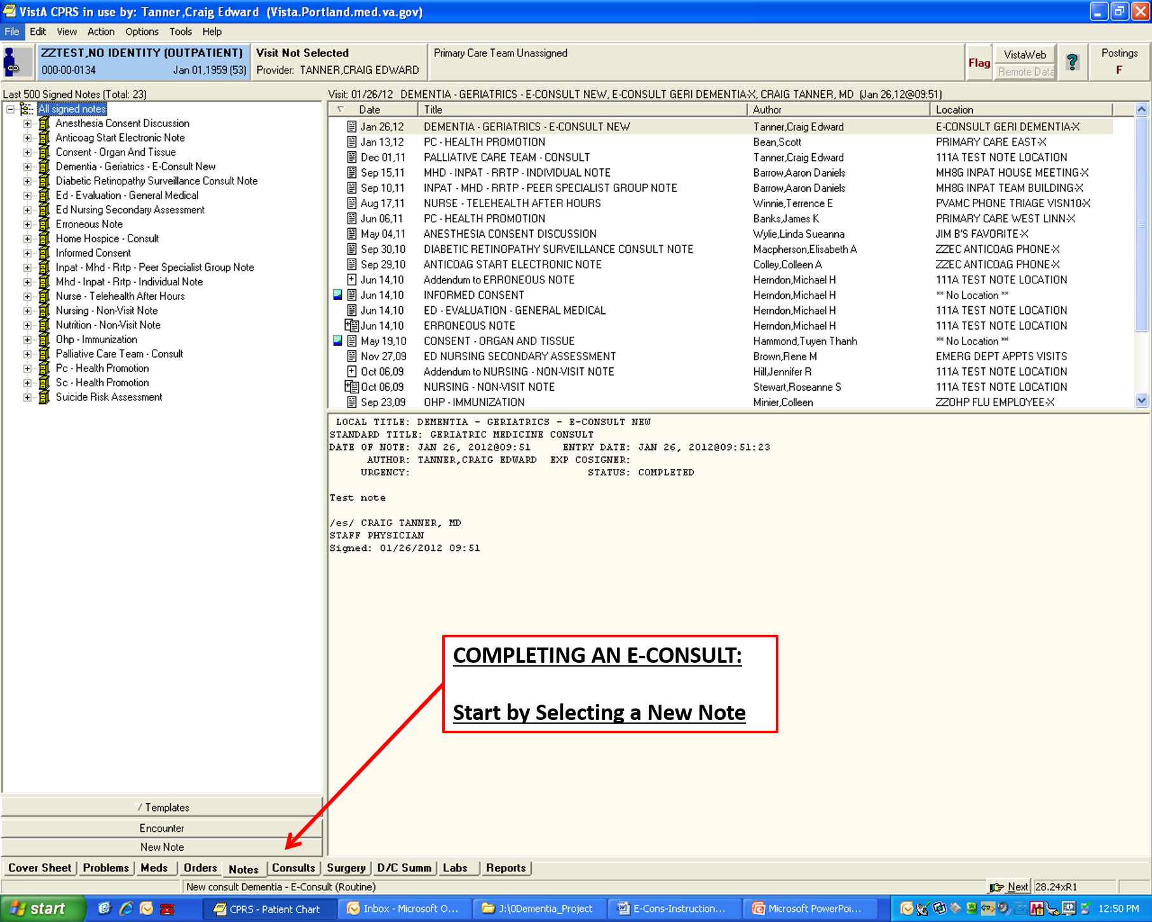

**Figure A.2. E- Consult Instructions (Image 2 of 13)**

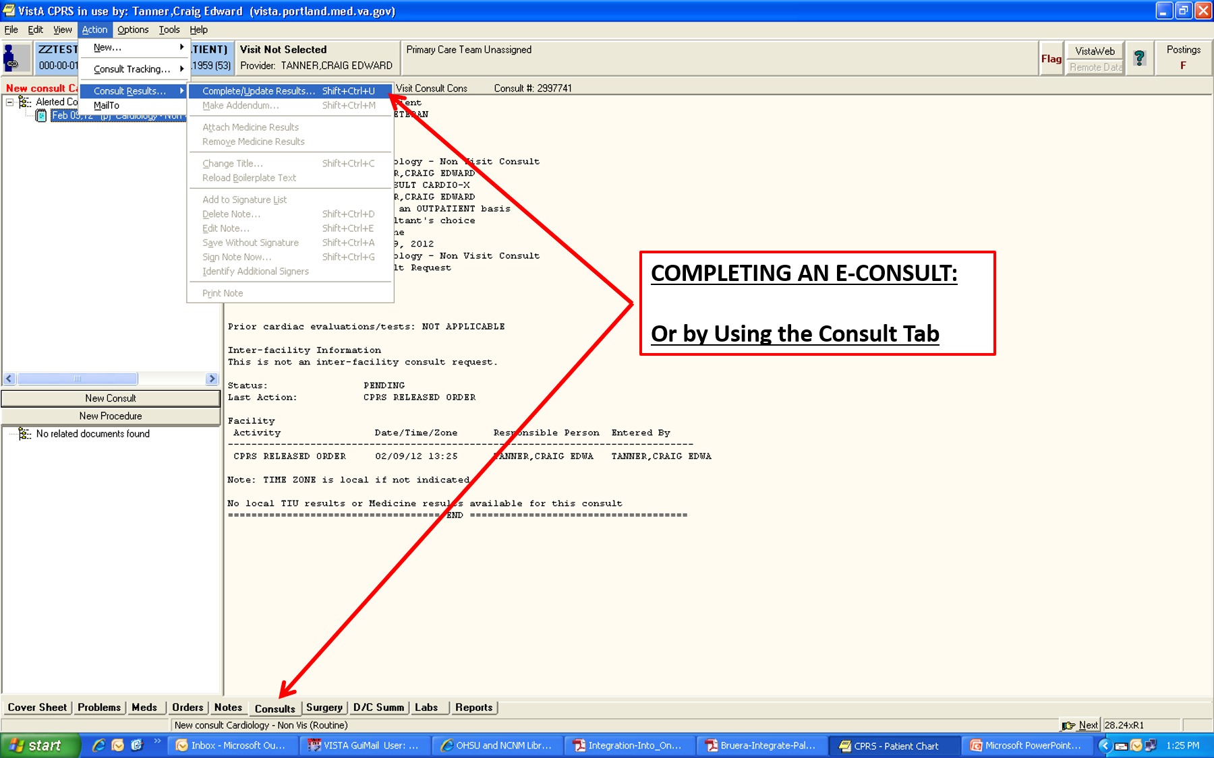

**Figure A.3. E- Consult Instructions (Image 3 of 13)**

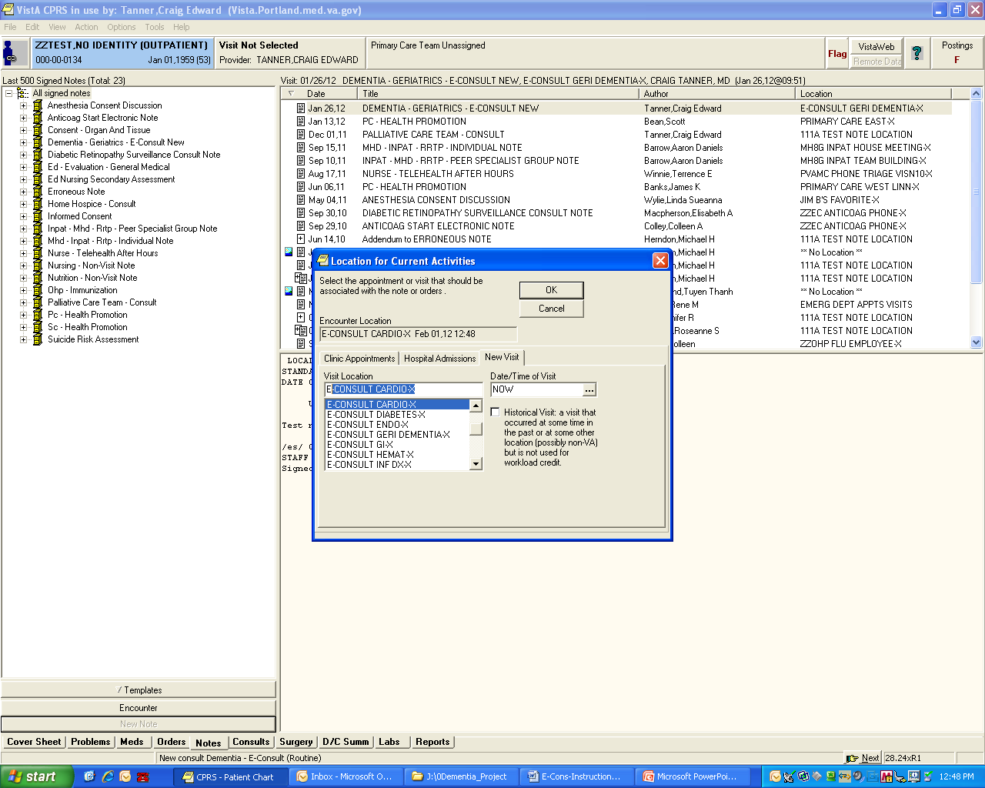

**Figure A.4. E- Consult Instructions (Image 4 of 13)**

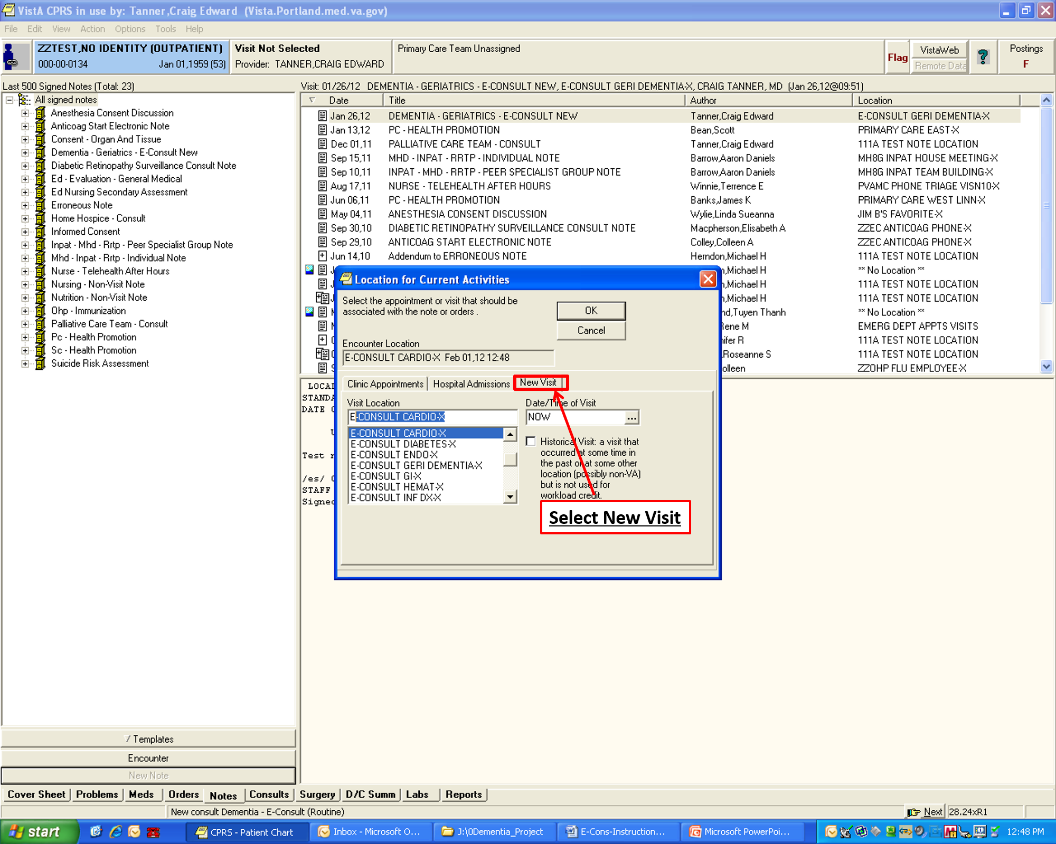

**Figure A.5. E-Consult Instructions (Image 5 of 13)**

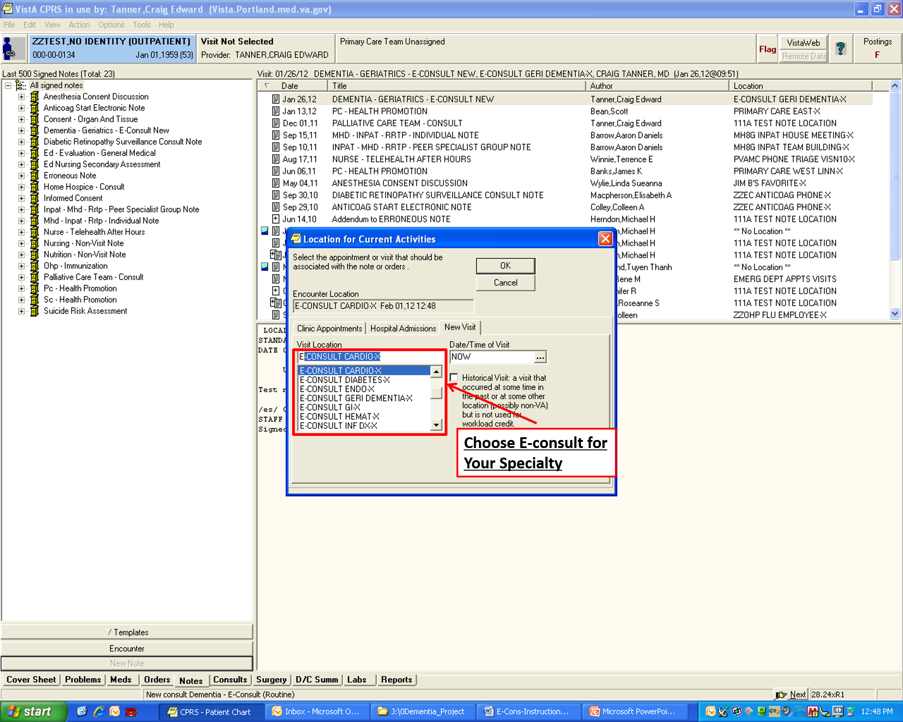

**Figure A.6. E-Consult Instructions (Image 6 of 13)**

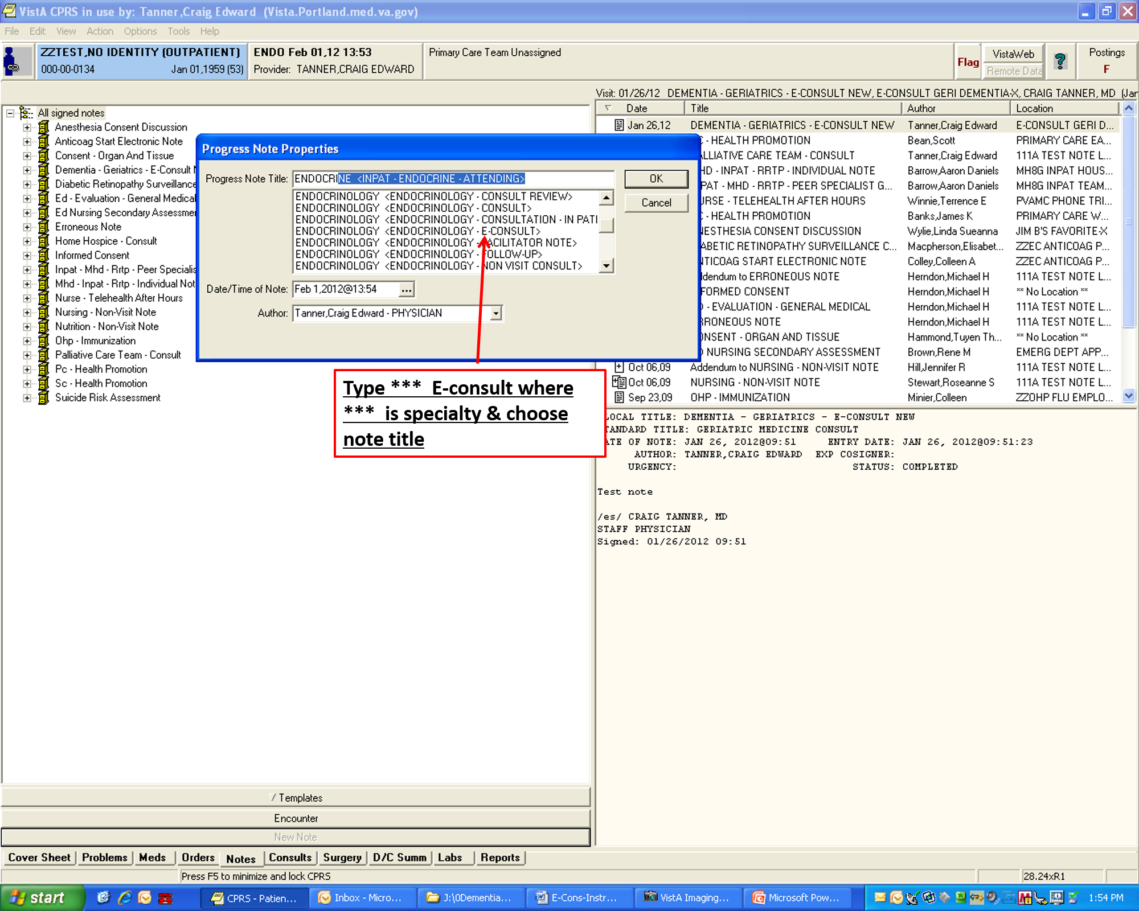

**Figure A.7. E-Consult Instructions (Image 7 of 13)**

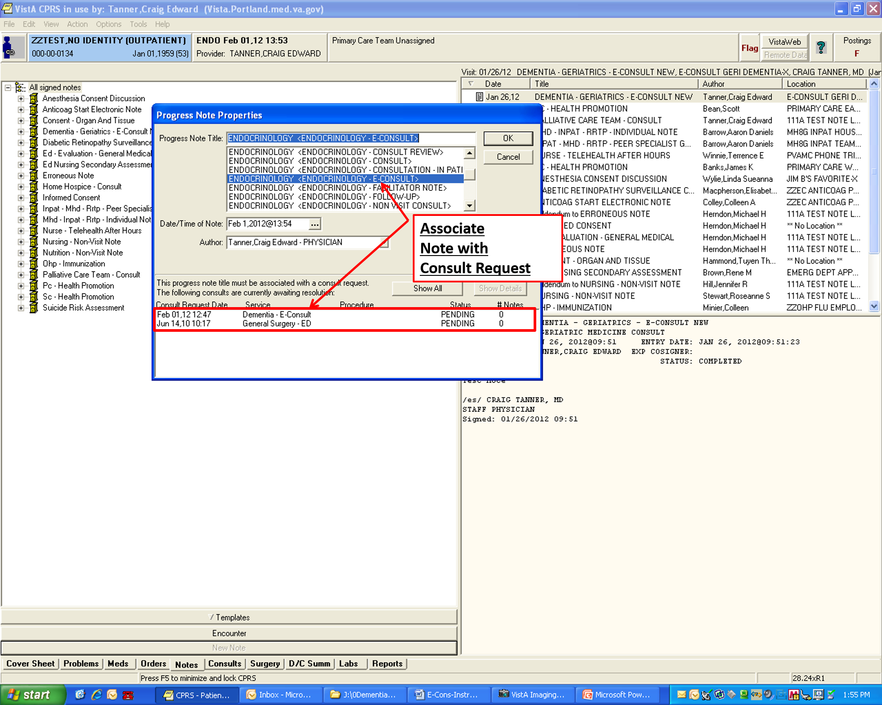

**Figure A.8. E-Consult Instructions (Image 8 of 13)**

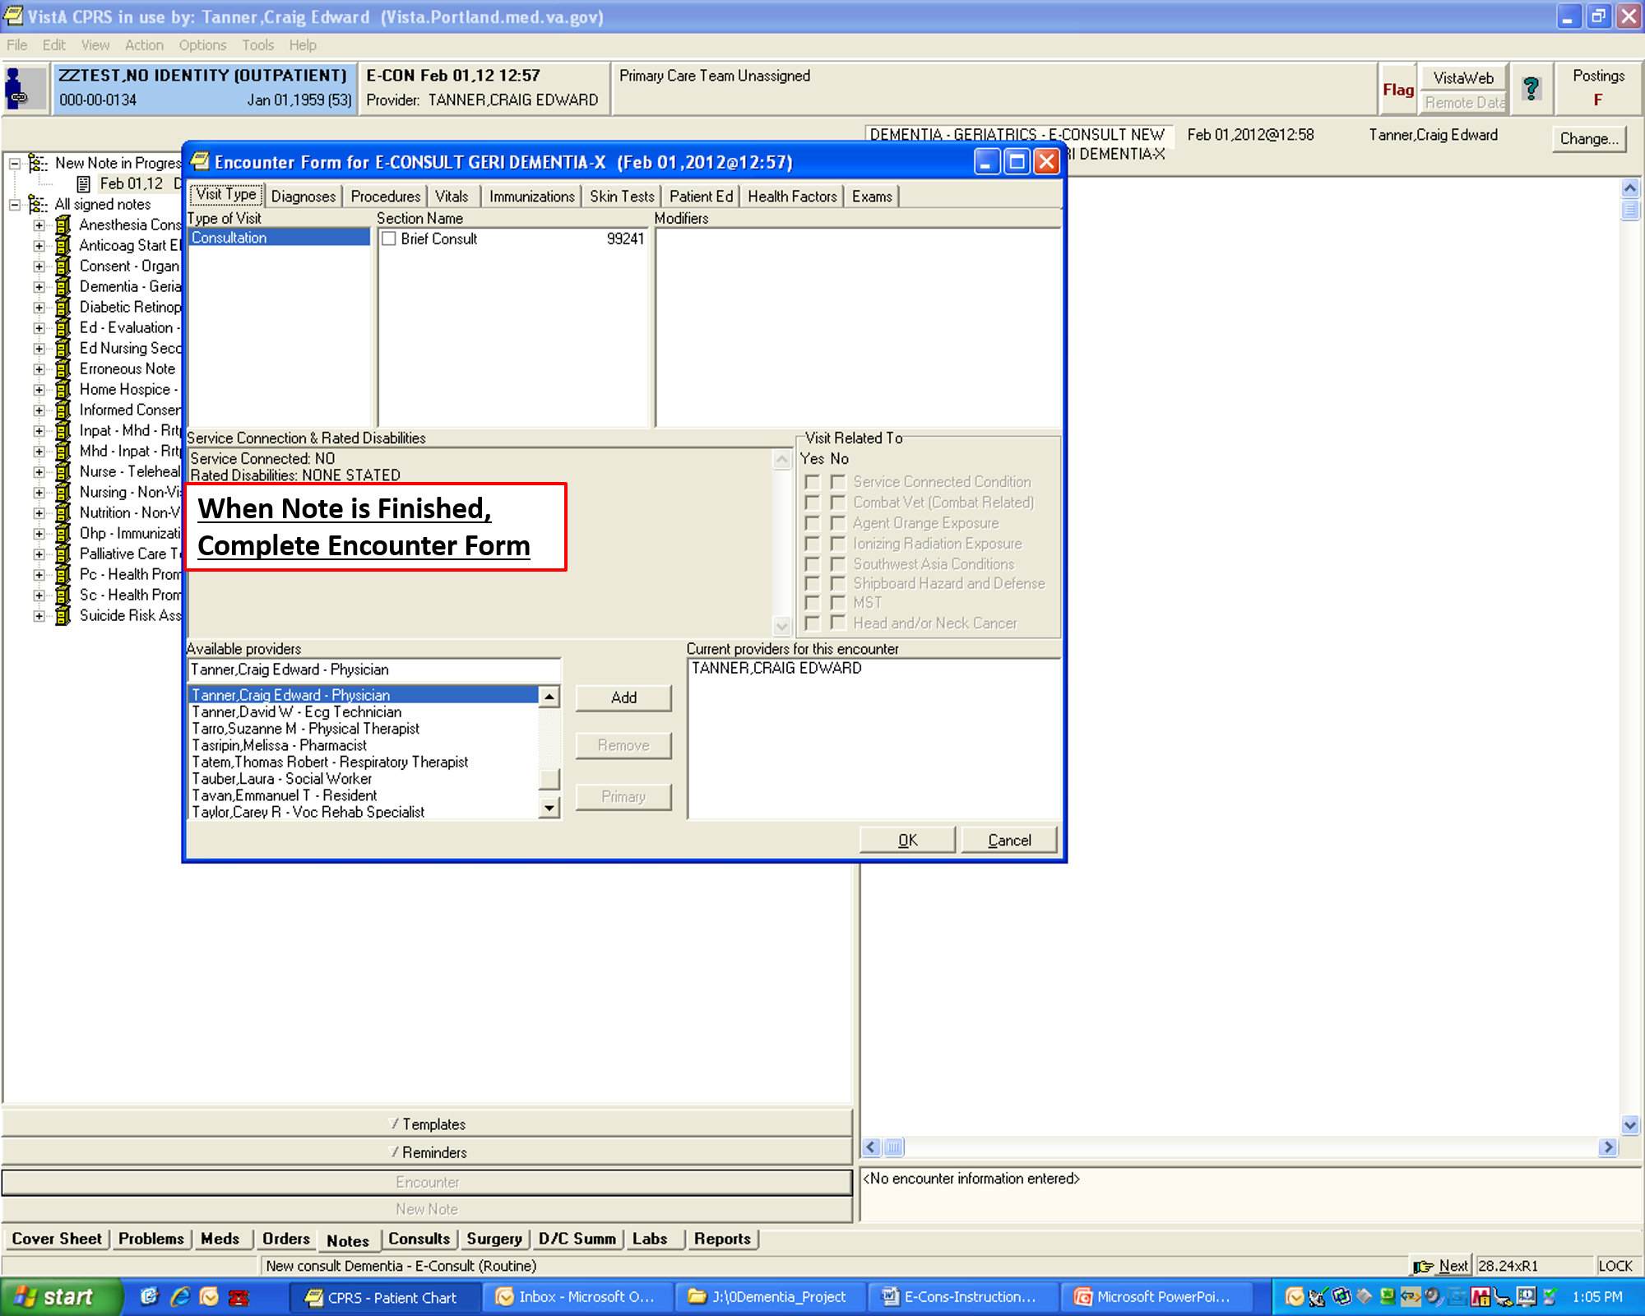

**Figure A.9. E-Consult Instructions (Image 9 of 13)**

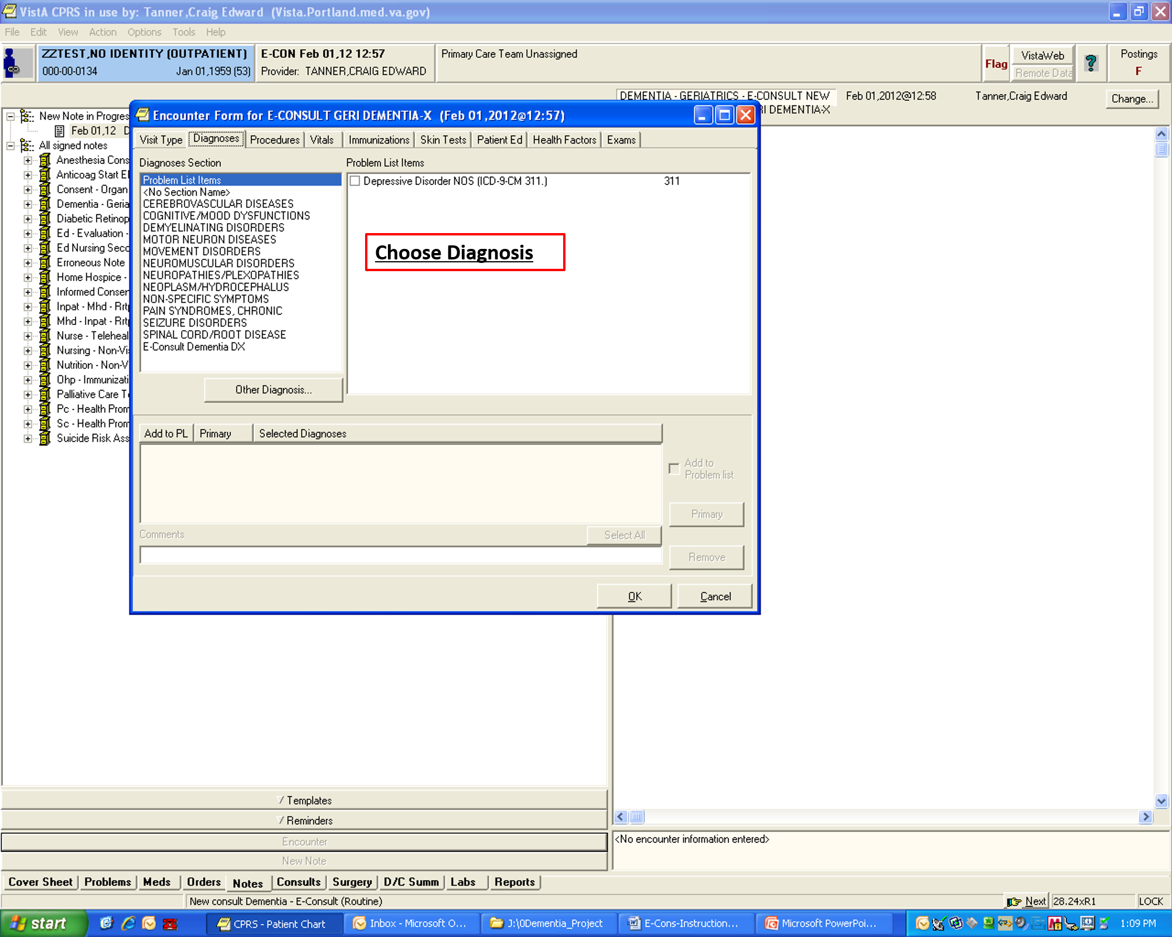

**Figure A.10. E-Consult Instructions (Image 10 of 13)**

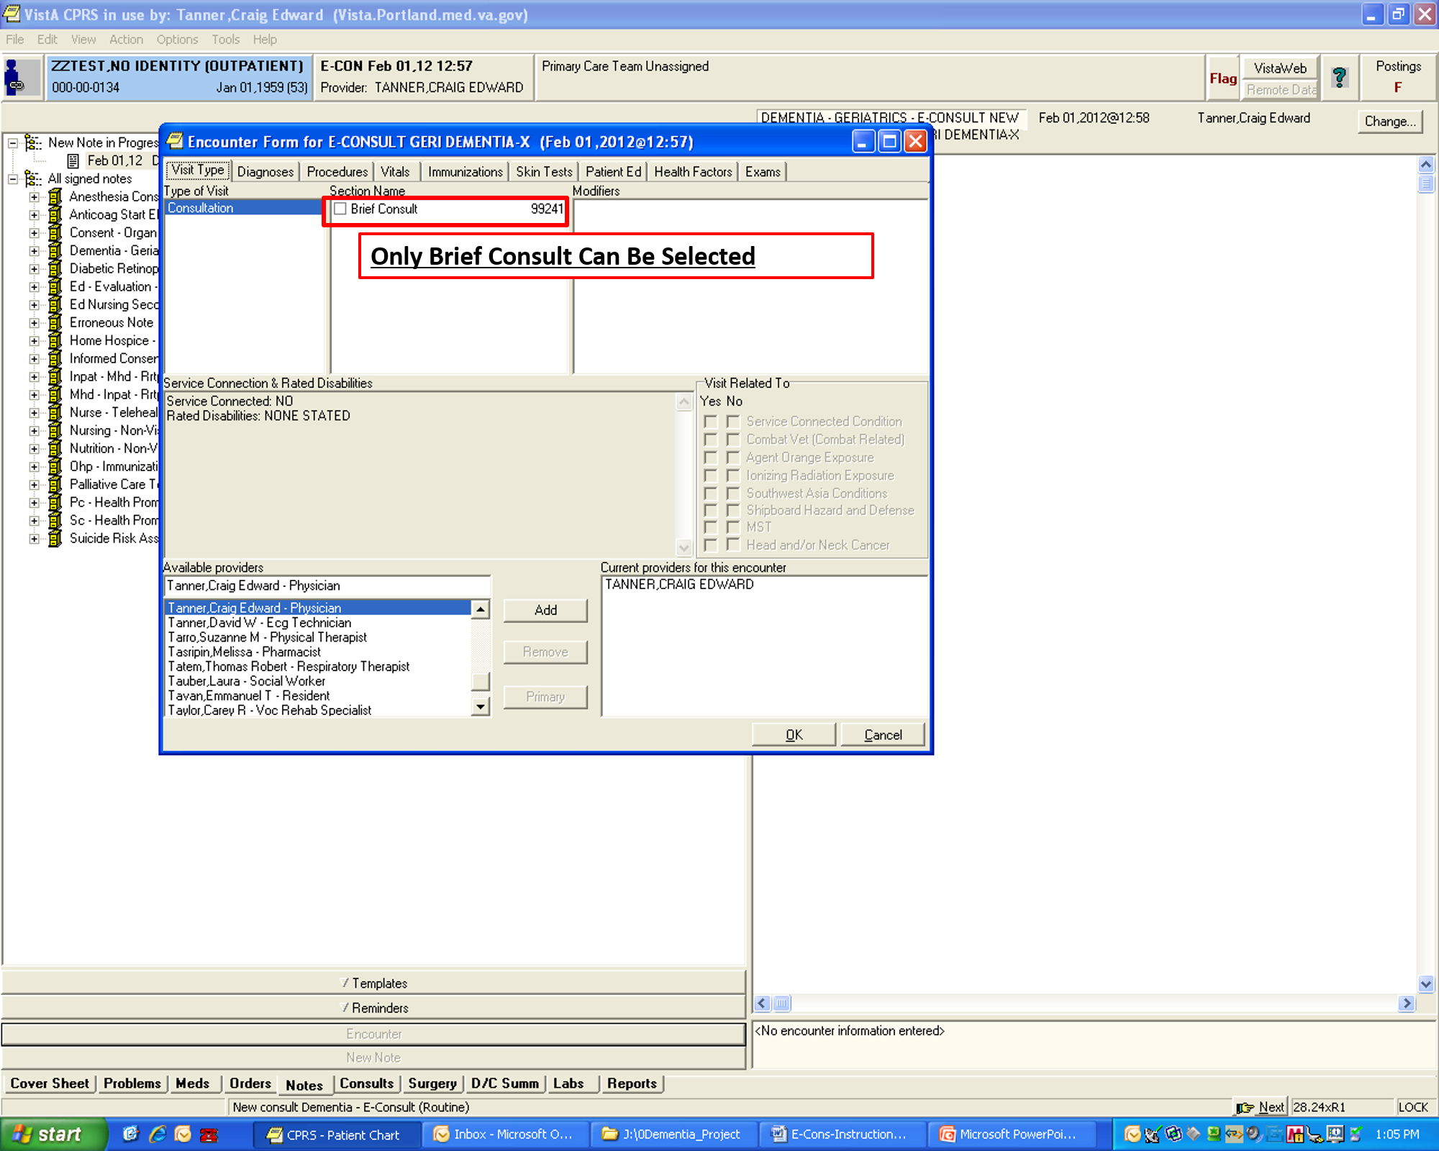

**Figure A.11. E-Consult Instructions (Image 11 of 13)**

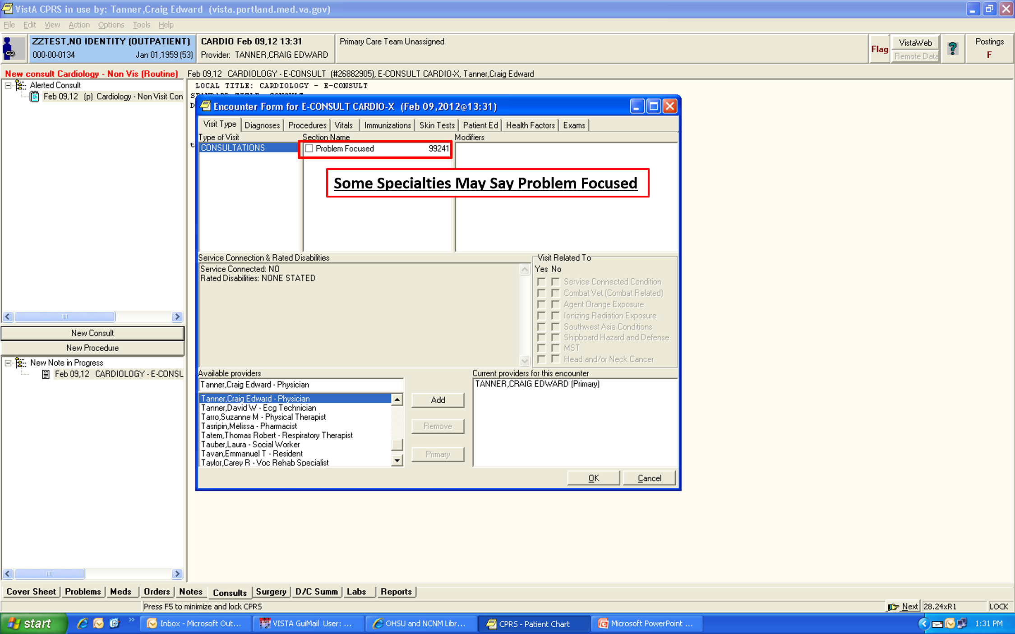

**Figure A.12. E-Consult Instructions (Image 12 of 13)**

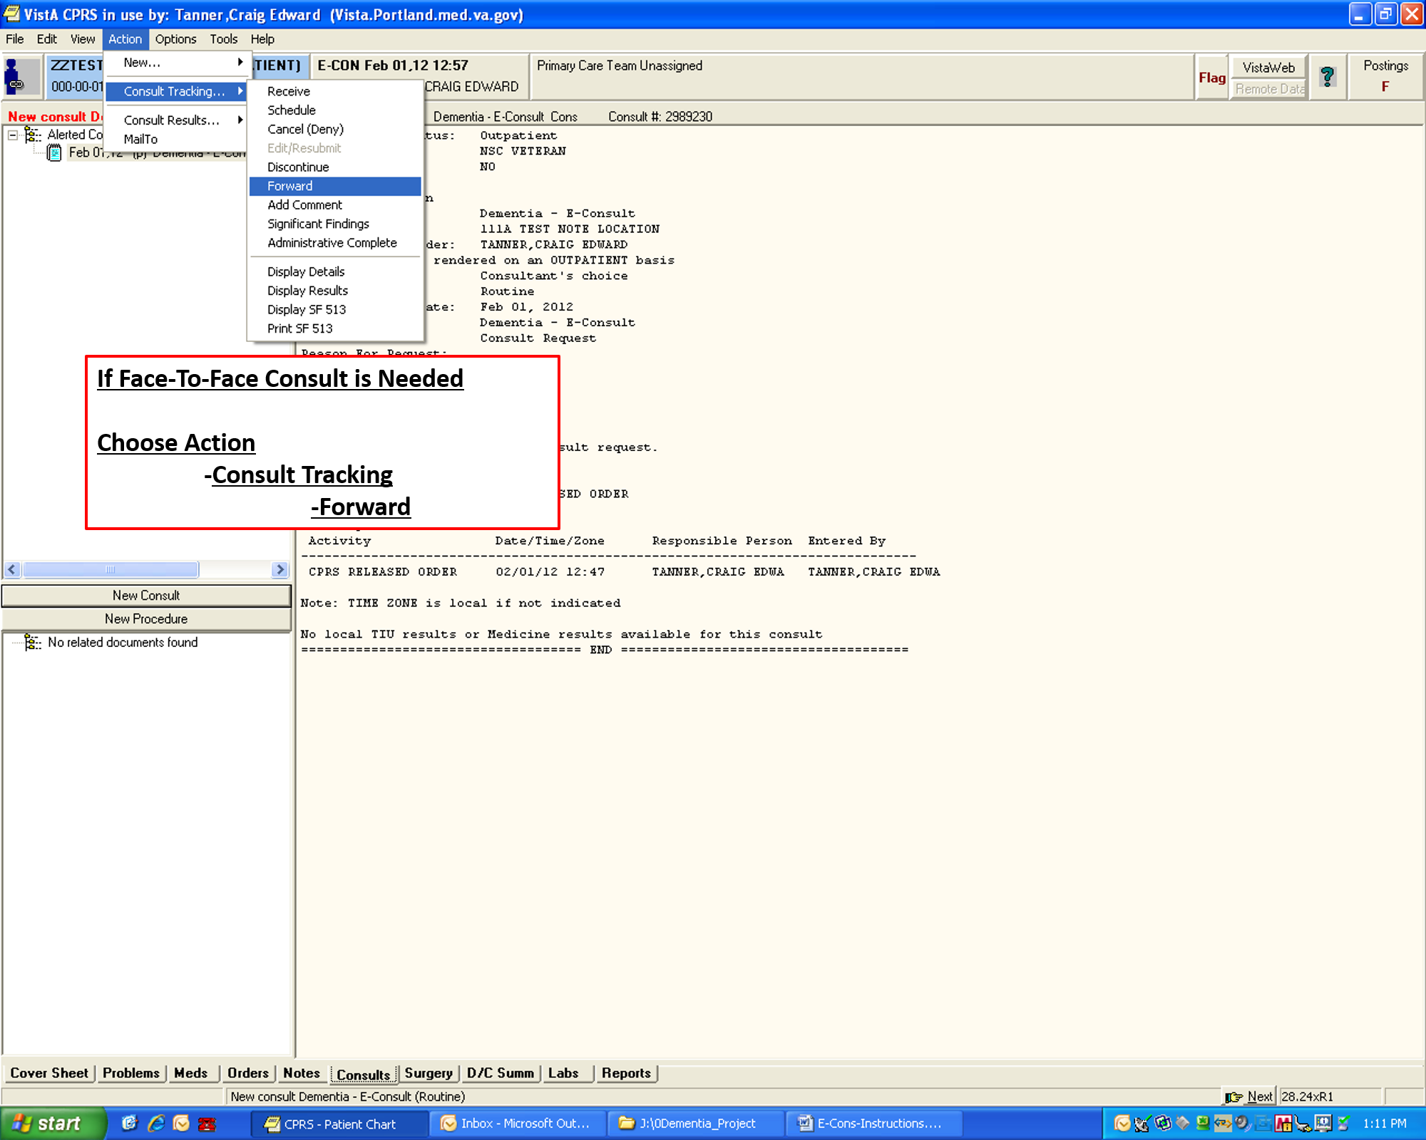

**Figure A.13. E-Consult Instructions (Image 13 of 13)**

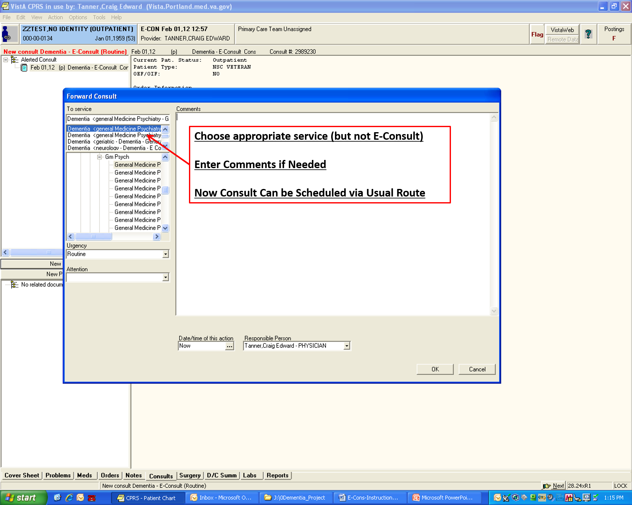

**Appendix B. Acronyms**

| **Acronym/Term** | **Description** |
| --- | --- |
| CCWP | Clinical Content White Paper |
| CDS | Clinical Decision Support |
| HL7 | Health Level 7 |
| KBS | Knowledge Based Systems |
| KNART | Knowledge Artifact |
| OIIG | Office of Informatics and Information Governance |
| SME | Subject Matter Expert |
| TO | Task Order |
| VA | Department of Veterans Affairs |
| VAMC | VA Medical Center |